Artificial Intelligence Memory P3

Done by: José Manuel López-Serrano Tapia, Sergio Hernández Martín.

**Exercise 1: slice/4**

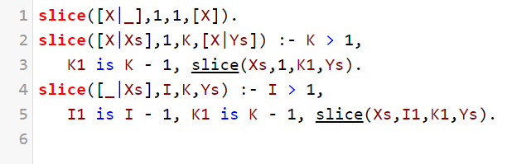

Code of the slice/4 predicate.

Declarative:

* For indexes 1, 1, the slice of a list requested is its first element.
* (K > 1) If the slice for Xs and indexes 1, K-1, is Ys, then the slice for [X|Xs] and indexes 1, K, is [X|Ys].
* (I > 1, K > 1) If the slice for Xs and indexes I-1, K-1, is Ys, then the slice for [_|Xs] and indexes I, K, is Ys.

Procedural (for the query slice([1, 2, 3 ,4], 2, 3, L2)), Xs=[1, 2, 3, 4], I=2, K=3, Ys=L2:

* First clause? No, I and K are greater than 1.
* Second clause? No, I is greater than 1.
* Third clause? Yes, we reach another slice predicate, with Xs’=[2, 3, 4], I’=1, K’=2, Ys=Ys’. Let us evaluate this clause.
* First clause? No, K’ is greater than 1.
* Second clause? Yes, we reach another slice predicate, with Xs’’=[3,4], X=2, I’’=1, K’’=1, Ys’=[X|Ys’’]. Let us evaluate this clause.
* First clause? Yes, we have reached the base case. Ys’’=[3] (first element of Xs’’). Ys’=[2,3]. Ys=[2,3].
* Tracing back we get our final solution, L2=[2,3].

**Exercise 9.5: clasifica_patrones/4**